NOAA GOES-R Radio User Guide

Installation Steps

(A). Run the Setup installation executable: GOES Receiver Setup.exe.

(B). Connect IF digitizer board to an available USB port, and turn on the ON/OFF switch

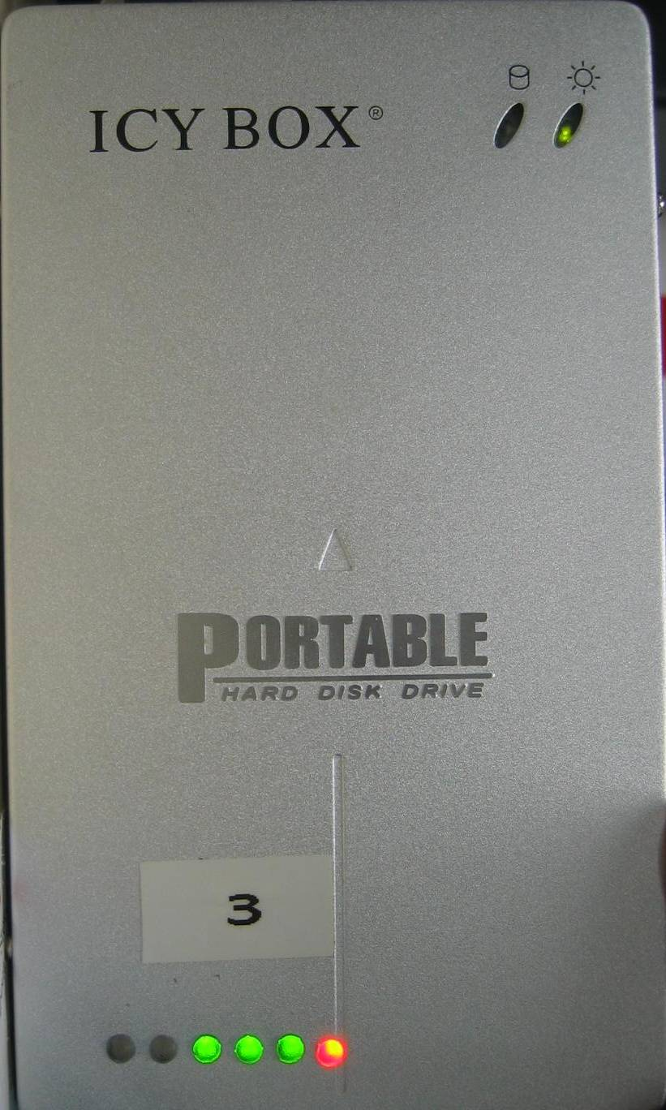

      - The first time you run the installation wizard, the system will detect the IF Digitizer. Follow the steps as indicated below:

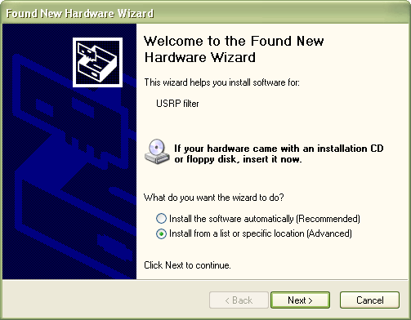
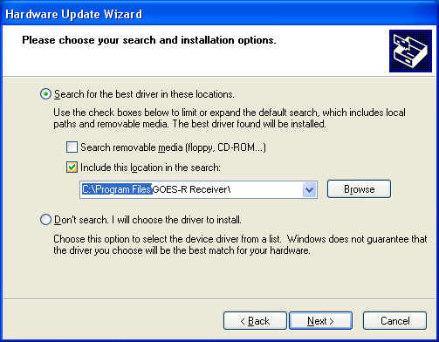

Select the driver folder as: “C:\Program Files\GOES-R Receiver\” or the equivalent installation directory chosen at installation time.

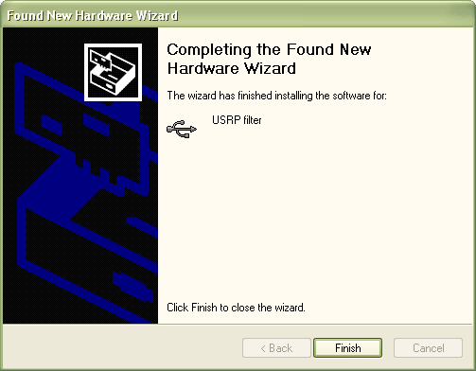

(C). Create a Windows Environment Variable called: “USRP_PATH”
In order to do this follow the steps below:
- Right Click on the “My Computer” icon and select “Properties”. The following window will pop up:

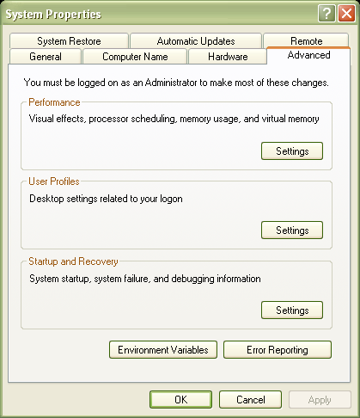

Select Environment Variables, and click on New, under the System Variable display
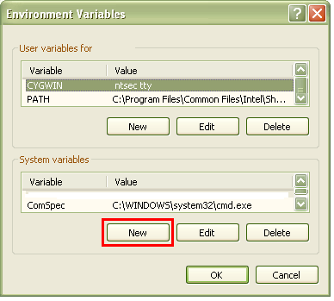

3. Add a System Variable Called “USRP_PATH” with
Variable Value: C:\Program Files\GOES-R Receiver\

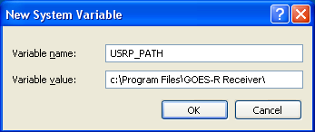

4. Add a System Variable Called “KMP_DUPLICATE_LIB_OK” with
Variable Value: TRUE

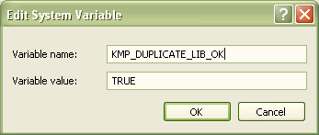

After installing the environment variables, the computer must be restarted.

During the installation, three new folders were created on your computer:

c:\EMWINTEMP
c:\LRITTEMP
c:\temp\usrp_log\input_data\

c:\EMWINTEMP stores the temporary gif, jpg, zip, and txt file products from the EMWIN Service
c:\LRITTEMP stores temporary .lrit image files from the LRIT service
c:\temp\usrp_log\input_data\ stores filter coefficients for digital lowpass filtering and interference rejection
Running the Software Radio Using the GUI

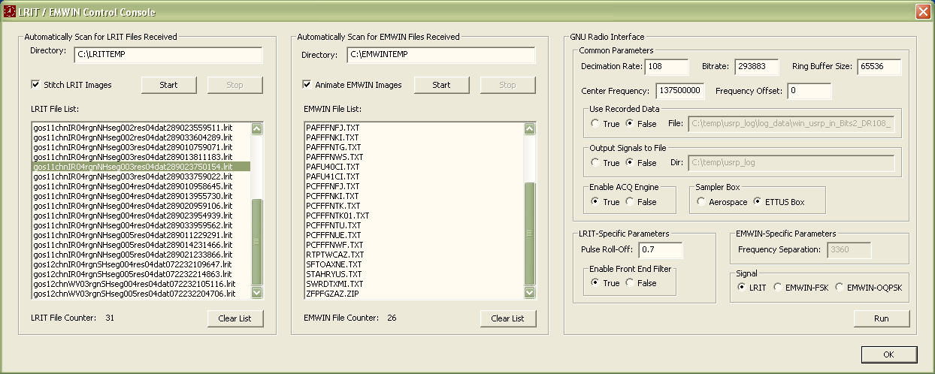
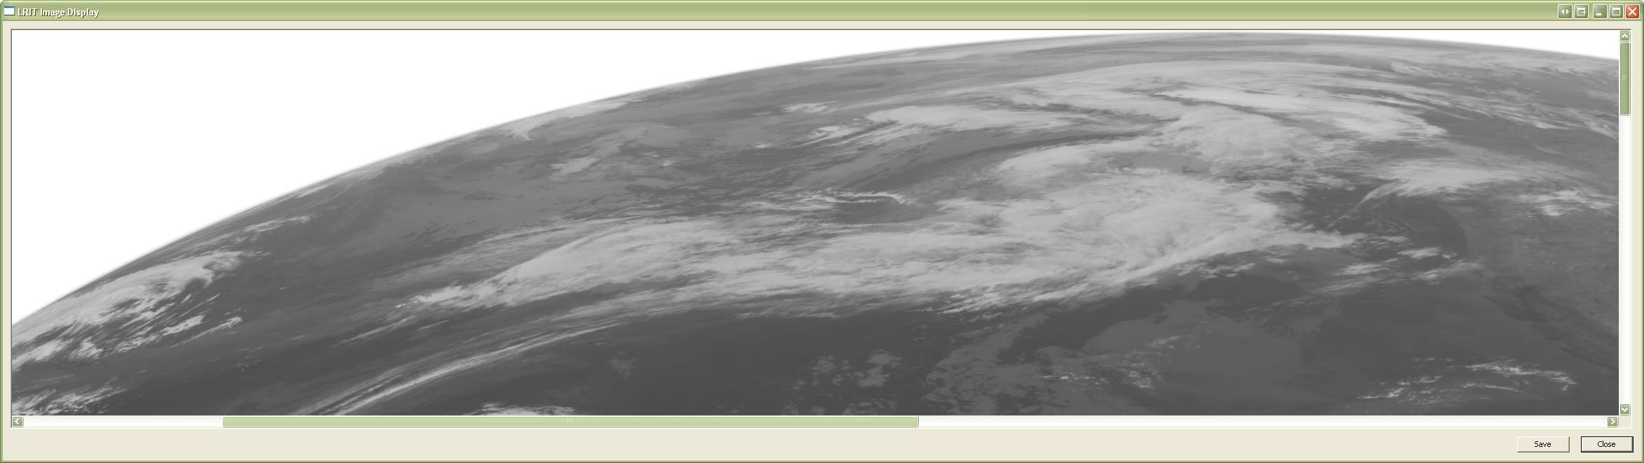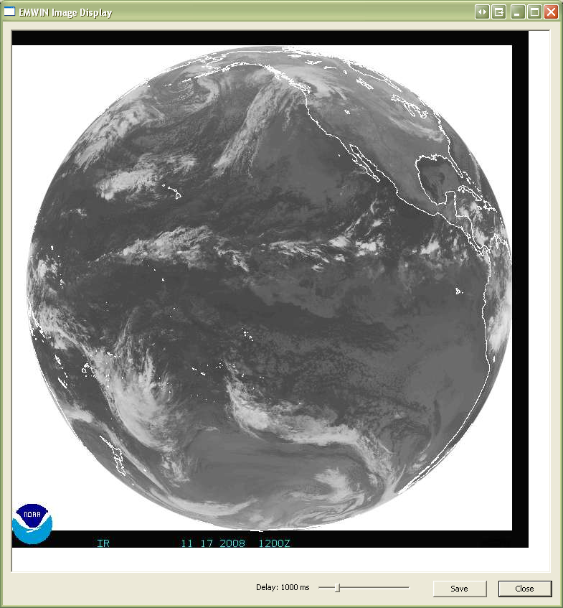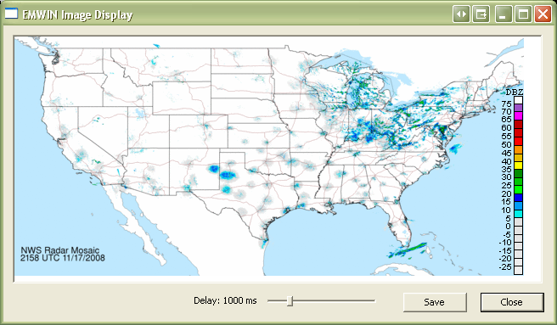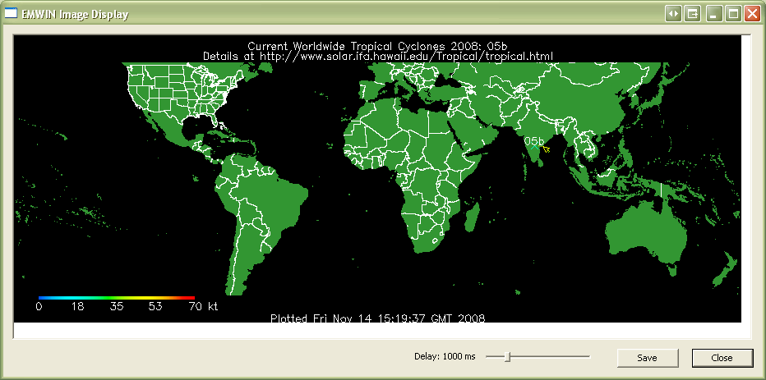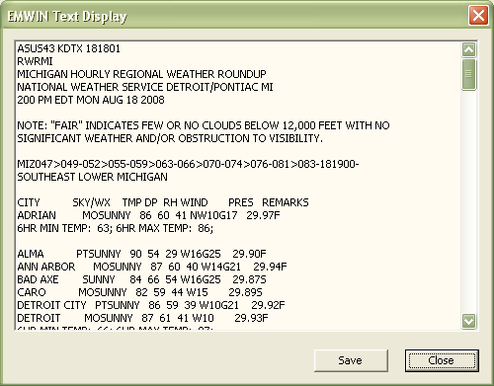
Figure 1: Graphical User Interface

To launch the application, execute Program Files\GOES-R Receiver\GOESPlayer.exe

In order to successfully operate the receiver, some parameters need to be set:

- Choose the desired signal type
The HRIT/EMWIN-R radio is able to receive three different signals. The LRIT – BPSK modulated signal, an EMWIN Offset Quadrature Phase Shift Keyed (OQPSK) modulated signal, and also an EMWIN Frequency Shift Keyed Signal (FSK) signal. Therefore the first step consists in choosing the appropriate signal to receive.
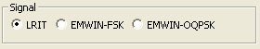
Figure 2: Choosing a Signal

- Manage the Data Display

When the software demodulates EMWIN and LRIT data, the files are stored in temporary folders on the desktop, c:\LRITTEMP, c:\EMWINTEMP. The Lritplayer.exe GUI actively checks and displays what files are in those temporary directories as shown in Figure 3. To ignore the temporary files that already exist in those folders, Click on the Clear List button for both LRIT and EMWIN. This does not delete the files in the folder, it merely ignores them. In order to command the GUI to display new files as they get written into those directories, you have to hit the Start button for both LRIT and EMWIN. Before every run, most users will likely begin by hitting the Clear List and Start buttons for both LRIT and EMWIN.
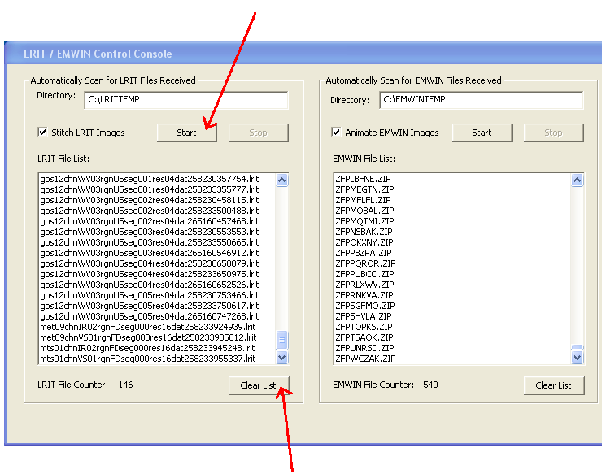
Figure 3: Starting LRIT/EMWIN File Scan

- Outputting Data Over a Socket

When the data is demodulated, LRIT and EMWIN products are stored locally in temporary folders, however, users also have the option of sending the demodulated data to 3rd party software for further processing. Figure 4 is a screen shot of the socket configuration field on the GUI. The GUI always outputs data to localhost (IP address 127.0.0.1), however the user can specify which port the data is sent over the localhost IP address. If the user wishes to send data to socket 127.0.0.1:18000, they would enter 18000 into the socket port field.

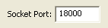
Figure 4: Socket Configuration

If you are a basic user, no further reading is required. If you are an advanced user (designer), the next sections will detail additional configuration options.

After the basic options have been set:

Click on the RUN button on the bottom left hand corner of the GUI.

- Running: LRIT – BPSK Modulated Signal

When running the software, the defaults are already established, so the user shouldn’t have to do anything accept choose the signals (LRIT, EMWIN) and hit RUN. There are additional options for greater control through the GUI, but these will not be used by the great majority of users.

Signal Characteristics:

Field | Value
Modulation | BPSK
Signal Frequency | 1691 MHz
RF Frequency | 137.5 MHz
Data Rate | 293.883 ksps
Sampling Frequency | 64 MHz
3rd Harmonic | 9.5 MHz
Decimation Ratio / Effective Samples Per Symbol | 1 / 217.77  54 / 4.03  72/3.0246  108 / 2.01
Table I: LRIT Signal. Default values shown in bold

The signal processing blocks required to receive GOES-R signals is shown in Figure 5. The interaction between the signal processing blocks from Figure 5 will be transparent to the user. Only a few input/output parameters will require configuration.

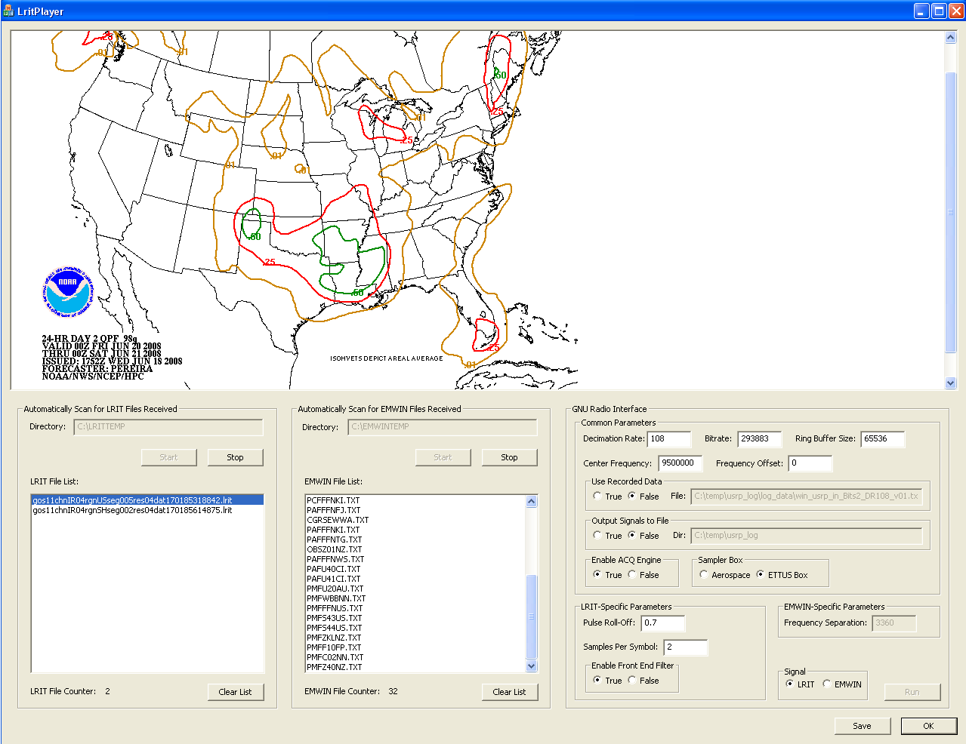
Physical Layer
Data Link Layer
Viterbi
Matched Filter
Phase Tracking
Mixer/AGC
Filter
Derandomization
Reed Solomon
Demux Packets
Decompress
Timing Tracking
Display
Application
GUI
From USB
Frame Synch
Text + Images
Figure 5: Data Flow

After choosing a signal, LRIT, EMWIN-N, or EMWIN-I, basic radio parameters are automatically set for the user. Advanced users can alter these options manually if they wish, as shown in Figure 6.

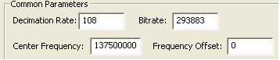
Figure 6: Common Parameters

- Decimation Rate:
This is used to determine the effective number of samples per symbol that will be used while sampling the received signal. It is important that the decimation rate is chosen such that the resulting number of samplers per symbol is as close to an integer as possible.

- BitRate:
This is the baud-rate (symbol rate) of the signal that is being demodulated. From Table I, LRIT has a baud-rate of 293883 symbols per second. Because this is a bi-level signal, the symbol rate and bit rate are equal.

- Center Frequency:
This is the center frequency at the 140 MHz IF. From Table I, LRIT typically goes from an RF of 1691 MHz to an IF center frequency of 137.5 MHz. Different Low Noise Block Downconverters (LNBs) might move LRIT to a different IF center frequency, so this option may be important to ensure compatibility across several front end systems.

- Frequency Offset:
If frequency acquisition is not used, the user can enter a desired frequency offset. This value will be subtracted from the Center Frequency and be used to center the down converter.

In order to correctly synchronize the receiver, a frequency acquisition algorithm is used to bring the signal down to baseband and eliminate all residual frequency offsets. Figure 7 shows how to enable this feature.

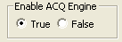
Figure 7: Enable Acquisition

Front End Filter:

The HRIT/EMWIN-R software radio can handle a wide gamut of frequencies in the 140 MHz band. The first stage hardware filter reduces the input bandwidth, but further filtering is needed to properly track the desired signals.

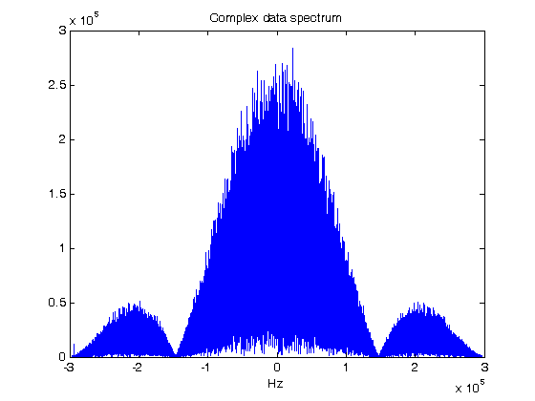
Figure 8: LRIT BPSK Signal Before Filtering

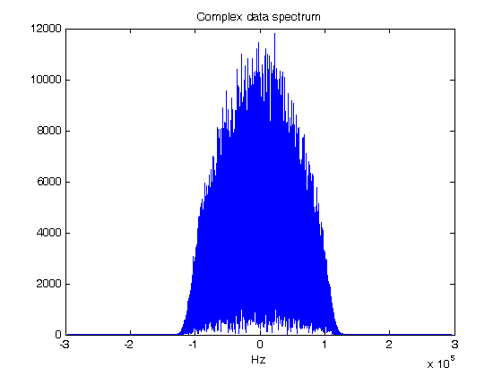
Figure 9: LRIT BPSK Signal After Filtering

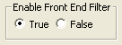
Figure 10: Enable Front-end Filter

A possibility of using previously recorded data to test the software radio has been incorporated to the graphical user interface (GUI).

To record data enable file logging by setting the flag in Figure 11 to “True”. By default our GUI is setup to use “live” data coming into the receiver. To enable the use of recorded data playback, set the flag in Figure 12 to True, and specify the folder with the location of the data file.

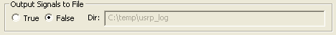
Figure 11: Write Intermediate Files

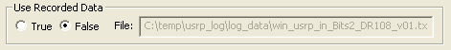
Figure 12: Live / Recorded Data

Image Animation
Certain types of EMWIN images have correlated surface information. These images can be continuously played backed to appreciate the effects of the surface variations. A slider at the bottom of the EMWIN Image Display window, enables the user to vary the speed of the playback frequency.

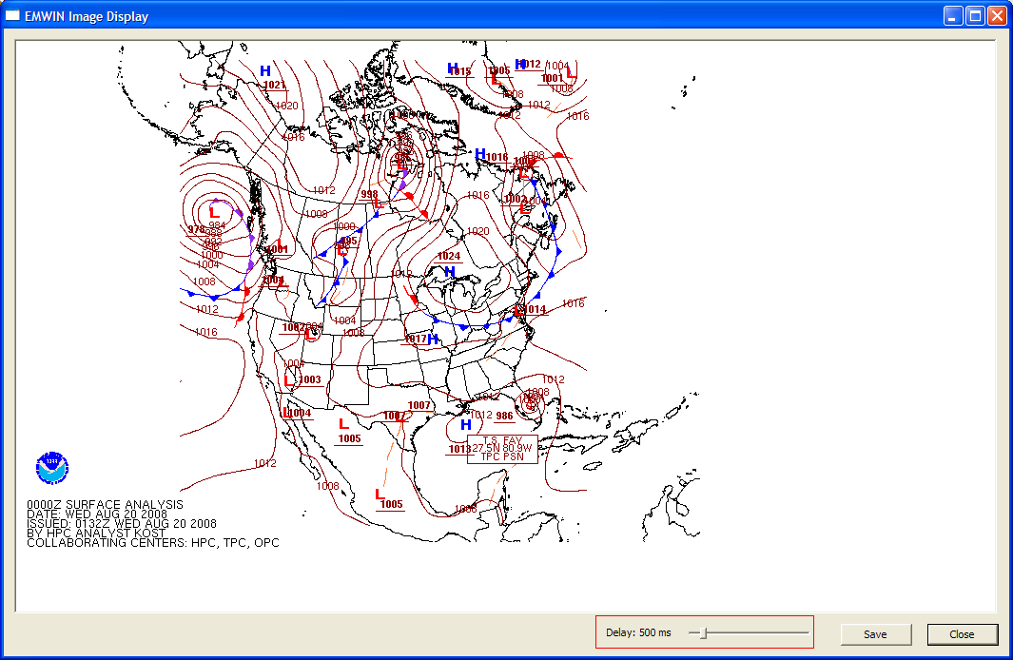
Figure 13: Animation of EMWIN Images

- EMWIN– OQPSK Modulated Signal
Signal Characteristics:

Field | Value
Modulation | OQPSK
Differential Encoding | YES
Signal Frequency | 1692.7 MHz
RF Frequency | 137.9 MHz
Data Rate | 17.970 ksps
Sampling Frequency | 64 MHz
3rd Harmonic | 13 MHz
Decimation Ratio / Effective Samples Per Symbol | 1 / 3561.5  88 / 40.47  178/20.00  222 / 16.00  254 / 14.01
Table II: OQPSK Signal. Default values shown in bold

- EMWIN–FSK Modulated Signal
Signal Characteristics:

Field | Value
Modulation | FSK
Differential Encoding | NO
Synchronous / Asynchronous | Asynchronous  (8,N,1): No parity bits, one start and stop bit
Signal Frequency | 1690.75 MHz
RF Frequency | 137.225 MHz
Data Rate | 9600 sps
Sampling Frequency | 64 MHz
3rd Harmonic | 9.25 MHz
Decimation Ratio / Effective Samples Per Symbol | 1 /6666.66  74 / 90.09  98/68.02  66 / 101.01
Table III: FSK Signal. Default values shown in bold

Running the Software Radio From the Command Line

This section is for very advanced users. In order to understand the full capabilities of the system, users are instructed to review the document “A Flexible Software Based EMWIN/HRIT Prototype Solution for the GOES-R Transition”. All algorithms and options treated in greater detail in that document.
The GOES-R receiver can be completely executed from the command line without using the GUI. To execute the system in command mode go to the command prompt and execute either EMWINHRIT, EMWINN, or EMWINI using the appropriate flags and options. EMWINHRIT is LRIT/HRIT-EMWIN radio, EMWINN is the EMWIN-N radio, and EMWINI is the EMWIN-I radio.
To find the available options, you can type the executable followed by help. Below is a screen demonstrating this.

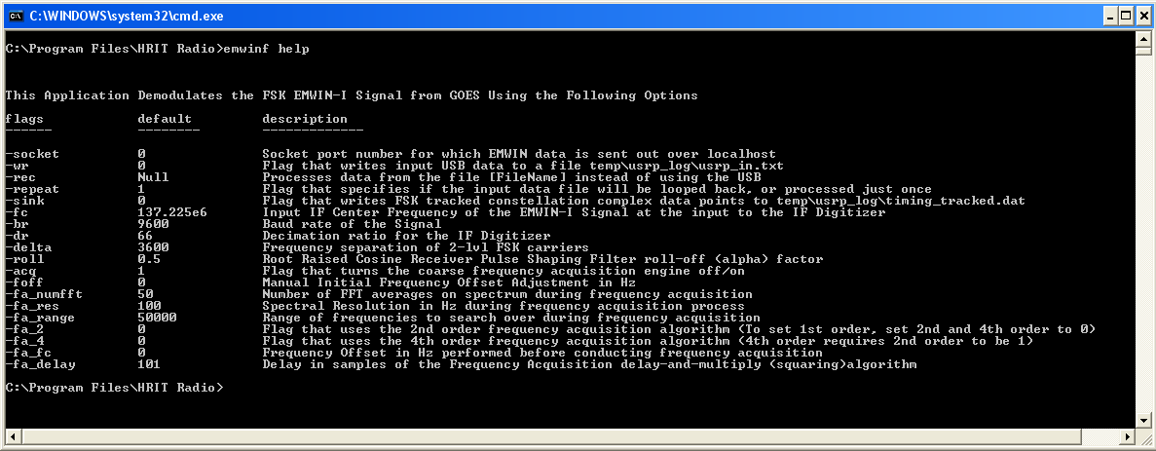

Below are tables summarizing the flags that can be used.

General Parameters
Parameter | Command Flag | Default Value | Description
Enable File Sink | -wr | 0 | Write raw USB samples directly to disk. Output file will be located in c:\temp\usrp_log\
Decimation Rate | -dr | Depends on Signal range: [2-256] | Sets the decimation rate on the FPGA. See Error: Reference source not found
Center IF-Frequency | -fc |  |  | For the LRIT Signal, default values is 137.5 MHZ, for EMWIN-I, 137.225 MHz, and for EMWIN-N is 137.9 MHz. 143.9 MHz for HRIT
Enable Software Filter | -lfilter | 1 |  | Enable software rejection filter
Repeat Incoming Waveform | -repeat | 0 |  | If the radio is run using a recorded user-file, this flag enables the receiver to repeat the incoming waveform once it reaches the end of file This is a useful feature for bit error rate testing
Roll off Factor | -roll | 0.5  Range: [.1 - .9] |  | Roll-off factor for square root-raised cosine pulse shaping
Bit Rate | -br | Depends on Signal |  | 293,883 for LRIT, 17970 for EMWIN-N, 9600 for EMWIN-I, 927,000 for HRIT.
Buffer Size | -buff | 64 [kbytes] |  | For multi-threaded applications, this parameter defines the size of the buffer between threads
Use Recorded Data ? | -rec | 0 |  | Allows software radio to run reading a pre-recorded file stored on a network drive instead of using data from the USB port of the AID box.
Timing Bandwidth | -tbw | 3000  [LRIT]  1000  [EMWIN-N] |  | Indicates the factor that divides the symbol rate of the desired signal to determine the timing-loop bandwidth for LRIT/HRIT and EMWIN-N only
Phase Bandwidth | -pbw | 100  [LRIT]  200  [EMWIN-N] |  | Indicates the factor that divides the symbol rate of the desired signal to determine the phased-locked-loop bandwidth for LRIT/HRIT and EMWIN-N only

Frequency Acquisition
Parameter | Command Flag | Default Value | Description
Enable / Disable Freq.Acq | -acq | 1 | Frequency acquisition is enabled by default.
Bin resolution | -fa_res | 50 Hz | Frequency bin-resolution
Freq. Range | -fa_range | 50 kHz | Initial frequency uncertainty to search for
Detection Rule
Square-Law | -fa_2 | 0 or 1 | Depends on signal of interest and SNR. Default method for OQPSK.
4th order Law | -fa_4 | 0 or 1 | Depends on signal of interest and SNR. Default method for BPSK.
Absolute Power |  |  | If Square and 4th Power are disabled, then this method is enabled. Used in some low SNR scenarios. Default for FSK.
FFT Averages | -fa_numfft | 16 | Number of times FFT algorithm is run to measure the frequency content of a specific bin
Forced Frequency Offset | -foff | 0 | User can set a desired frequency offset that adds to the value that the frequency algorithm obtains. Or one can turn acquisition off, and enter in a known offset manually.

Soft Decision Viterbi Decoding
Parameter | Command Flag | Default Value | Description
Minimum Threshold | -vthresh | 0.1 | Minimum bit error rate at the output of the Viterbi block, to declare that the decoder has solved its phase ambiguity
Test for Cycle Slip | -vperiod | 10 | Indicates number of blocks before the Viterbi subroutine verifies that it is locked to the correct phase. For BPSK there are 2 possible states only. For OQPSK there are four.

