**Technical Support Document:**

**Resource Adequacy and Reliability Analysis  
August 2015**

This document describes resource adequacy and reliability impacts of the final rule emission guidelines issued under section 111(d) of the Clean Air Act, also known as the Clean Power Plan. As used here, the term *resource adequacy* is defined as the provision for adequate generating resources to meet projected load and generating reserve requirements in each power region[1], while *reliability* includes the ability to deliver the resources to the loads, such that the overall power grid remains stable.

It is important to recognize that the final rule provides multiple flexibilities that preserve the ability of responsible authorities to maintain electric reliability, as well as a provision to ensure that electric reliability is adequately maintained in the case of extreme circumstances, amongst other changes to the final rule that will assist states and other authorities with ensuring adequate supplies of electricity and maintaining electric reliability. For more detail on how the final CPP addresses reliability, see Section VIII of the final rule preamble. The results presented in this document show that power system impacts of the final rule on system operations, under conditions preserving resource adequacy, are modest and manageable.

First, the final rule includes critical timing adjustments in response to comment about resource adequacy and reliability. In particular, the start date for the first compliance period was moved from 2020 to 2022. In addition, building block 2 and building block 3 are both gradually phased in starting in 2022 to give EGUs additional time to make adjustments, including any investments needed for the purpose of ensuring resource adequacy and reliability.

Second, as with the proposal, the final rule offers considerable flexibility to both states and EGUs. States are given broad latitude to design plans that fit their unique circumstances, including taking into account any resource adequacy or reliability constraints they may face. One particularly important example of this latitude is that states are encouraged to implement mass-based or rate-based plans that allow EGUs to take advantage of trading both within each state and across states. Moreover, states are given additional flexibility to manage any near-term resource adequacy constraints by taking advantage of averaging provisions during the interim multi-year compliance period from 2022-2029.

Finally, the Reliability Safety Valve (RSV) provisions in the final rule provide additional flexibilities and provisions that assure states can adequately manage any specific reliability challenges that may arise.

In sum, states can choose different ways of implementing the rule guidelines to meet their targets while meeting their specific needs and maintaining electric reliability. For more detail on the RSV and other ways in which the how the final CPP addresses reliability, see Section VIII of the final rule preamble.

The results presented in this document further demonstrate, for the specific cases illustrated in the Regulatory Impact Analysis (RIA), that the implementation of this rule can be achieved without undermining resource adequacy or reliability. The focus of the analysis is on comparing two illustrative state plan scenarios from the RIA to a base case (absent the rule requirements) that is assumed to be adequate and reliable. In this framework, the emphasis is on the incremental changes in the power system that are projected to occur under the presence of the rule.[2] The EPA uses the Integrated Planning Model (IPM) to project likely future electricity market conditions with and without the proposed rule.[3]

IPM is a multi-regional, dynamic, deterministic linear programming model of the U.S. electric power sector. It provides forecasts of least cost capacity expansion, electricity dispatch, and emission control strategies while meeting energy demand and environmental, transmission, dispatch, and reliability constraints. The model is designed to reflect electricity markets as accurately as possible. The EPA uses the best available information from utilities, industry experts, gas and coal market experts, financial institutions, and government statistics as the basis for the detailed power sector modeling in IPM. The model documentation provides additional information on the assumptions discussed here as well as all other model assumptions and inputs.[4]

IPM’s least-cost dispatch solution is designed to ensure generation resource adequacy, either by using existing resources or through the construction of new resources. IPM addresses reliable delivery of generation resources for the delivery of electricity between the 64 IPM regions, based on current and planned transmission capacity, by setting limits to the ability to transfer power between regions using the bulk power transmission system. Within each model region, IPM assumes that adequate transmission capacity exists to deliver any resources located in, or transferred to, the region. This document focusses on key regional results important to management of the power system. For a more complete presentation of the broad power sector impacts of the proposed rule, see the Regulatory Impact Analysis.

**Overview**

In the final rule, the EPA is establishing emission guidelines for states to use in developing plans to address greenhouse gas emissions from existing fossil fuel-fired electric generating units. Specifically, the EPA is proposing category-specific performance rates for CO2 emissions from power plants, as well goals for states to use in developing plans to meet the guidelines. See final rule preamble for more detail on the final CPP structure and rule requirements. This TSD uses the same scenarios and years of analysis contained in the RIA.[5] The scenarios include a base case (no CPP), a rate-based state plan scenario and a mass-based state plan scenario. For purposes of this resource adequacy and reliability assessment, estimates and projections are taken from those same scenarios and years as shown in the RIA (2020, 2025, and 2030).

**CPP Rate-Based Scenarios**

**Summary of Changes in Operational Capacity**

Total operational capacity is lower in the CPP scenario, primarily from the reduced need for existing and new capacity as a result of increases in energy efficiency. These increases in energy efficiency make possible increases in retirements compared to the base case. Since most regions currently have capacity above their target reserve margins, most of these retirements are absorbed by a reduction in excess reserves in the early years. For illustrative purposes, the 2025 projection period, the first period to fall entirely within the compliance period, is discussed first, followed by discussion of 2020 and 2030. Operational generating capacity[6] changes from the base case in 2025 are summarized below:

|  |  |  |
| --- | --- | --- |
| Table 1. Operational Capacity Summary in 2025 | | |
| Base case operational capacity (MW) |  | 1,037,223 |
|  |  |  |
| *Minus* Retirements in CPP Rate Case: |  |  |
| (-) Coal |  | -22,984 |
| (-) Oil-Gas Steam |  | -9,264 |
| (-) Combustion Turbine |  | -1,942 |
| (-) Combined Cycle |  | -1,643 |
| (-) Nuclear |  | -1,128 |
| (-) Less New Capacity due to EE Reduction |  | -12,626 |
|  |  |  |
| *Equals* Policy Case Operational Capacity |  | 988,764[7] |

Since the model must maintain adequate reserves in each region, a portion of the reduced operational capacity in the CPP rate based policy case is taken from reduced need for reserves compared to the base case. In order to maintain resource adequacy in each region where existing resources retire, the model relies on any excess reserve that are available from continuing to operate existing capacity, additions of new capacity, reduced total resource requirements from increases in energy efficiency, and the ability to shift transmission among regions as the generating capacity mix changes. As the table shows, the reduced resource needs permit lower capacity additions even though there are substantial increases in retirements. Each of these CPP rate based policy case changes is discussed further below.

**Reduction in Reserve Requirements and Excess Reserves**

IPM uses a target reserve margin in each region[8] as the basis for determining how much capacity to keep operational in order to preserve resource adequacy. IPM retires capacity if it is no longer needed to provide energy for load or to provide capacity to meet reserve margin during the planning horizon of the projections. Since current regional reserves are generally higher than the target reserve margin for the region, and increased energy efficiency will reduce the need for reserves, IPM may retire reserve capacity in 2025 if it is not economic to use it to maintain adequate reserve margins. Existing resources may also be more expensive, compared to alternatives such as building new capacity or transferring capacity from another region. As a result, many of the plants that are projected to retire in 2025 will not need to be replaced. Because existing plants eventually retire in most regions, and IPM builds no more than what it needs to maintain a target reserve margin in each region, the actual reserve margins tend to approach the target reserve margins over time.

Table 1 above shows that operational *generating* capacity is reduced by 48,587MW (4.8 percent) nationwide in 2025 under the policy.[9] The majority of this reduction is the result of decreases in the reserve requirements from energy efficiency under the final rule; in 2025 new energy efficiency under the final rule contributes 45,085 MW to reserve capacity[10] (see Table B1 for regional detail). Moreover, these reductions are from energy efficiency that is available in all hours, not just at peak, so it can substitute for existing or new baseload capacity. A reduction of 4.7 percent in 2025 will therefore have little overall impact, particularly given the length of time available to plan for any system changes. Moreover, retirements are distributed throughout the power grid, so any impacts are expected to be small at the regional level.[11]

Although there are substantial existing regional variations in reserve margin, IPM adjusts regional operating capacities in 2025 to meet the specific target reserve margin in each region, through changes in the level of retirements, construction of new generating capacity, or transfers of capacity among regions to meet the specific reserve margin in each region. Each of these adjustments in the 2025 projections is described below.

**Changes in Retirements and New Capacity Additions in the CPP Scenarios[12]**

The incremental retirements in the final rule case are shown above in Table 1; the 36,931 MW of retirements are in addition to 69,254MW of coal and 12,973MW of oil/gas retirements already occurring in the base case.

By 2025, the increased level of energy efficiency in the CPP case, compared to the base case, leads to lower levels of overall new capacity additions (shown regionally in Table A5). Renewable additions are approximately the same in both the base and policy cases, largely a result of reduced demand compared to the base case. The largest decreases in new capacity are in NGCC (7,808MW) and CT (3,131MW). Although there can be local grid reliability issues in replacing some units, these are expected to be manageable within the normal reliability planning and management time frames provided by the flexible resource options and time frames in the rule. These retirements and additions in the projections are the result of economic planning for energy and capacity needs modeled in the projections, they are not forced on individual units. In particular, new additions in a base case scenario that do not occur in the policy scenario projections might, in reality, be retained under a policy if local reliability conditions rendered this the most appropriate choice. This rule does not prevent generation owners from shifting retirements and additions among specific sources to ensure reliability in such circumstances.

**Reserve Transfers**

In cases where it is economic to transfer reserves from a neighboring region, rather than supply reserves from within a region, IPM will transfer reserves, subject to summer and winter limits that are designed to ensure that these reserves can be transferred reliably. The transfer of reserves can occur, for example, if a region retires capacity that was used in the base case to meet reserve requirements, but a neighboring region has lower cost reserves that are not needed for its own reserve requirements. To examine these transfers, the EPA analyzed the change in net transfers from each region, where the net transfer for the base and policy cases is measured by the reserves sent to neighboring regions. In these cases, a positive value signifies the reserve capacity sent to other regions is larger than the reserve capacity received from other regions (sending and receiving regions can be different), while a negative value signifies that the capacity received is larger than the capacity sent. Thus, the value measures the degree to which resources in the region were reserved for use by other regions (positive value), or where the capacity to meet load in the region was served by resources in other regions (negative value). In each case these reserve transfers represent the use of the transmission system on a firm basis for at least a season.

To look at the impact of the CPP case on transfers, the measure used was the change in the summer reserves sent in the policy case compared to the base case. To develop a relative measure of the impact of the policy, the change in reserves was measured as a percentage of load in the sending region. This percentage gives an indication of the significance of the policy for changes in the grid. In general, the percentage changes in the final rule are below the changes in the proposed rule, and all are below 5%.[13]

Using this measure, the largest percentage changes in reserve transfers are in the Northwest (4.3%), SERC-North (-3.5%), and FRCC (3.1%). The change in the Northwest is attributable primarily to change in transfers from the Pacific Northwest IPM region to California, where an additional 2000MW are transferred to Northern California, including 1000MW shifted from Southern California (LADWP). The net change of 1,134(MW) occurs, in part, as a result of additional operating capacity made available by increased energy efficiency in the policy case compared to the base case. This shift does not indicate any reliability challenges, as the total transfers of 3,499MW in the policy case remain substantially below the transfer limit of 4,200MW.

The SERC regions and FRCC have shifts around three percent, with some areas increasing net transfers and others decreasing. These areas also saw shifts in transfers in the modeling for the proposed rule, but the changes in this final rule have reduced these shifts to modest transfers compared to the proposal. In general, the shifts under the final rule show transfers from the Southeastern areas with greater natural gas resources available – FRCC and SERC-SE – toward northern areas with greater amounts of coal -- TVA and Kentucky. These transfers in the modeling remain well below the interregional transfers limits and 3 percent or less of the regional load in each case, and it is reasonable to expect them to be manageable, if needed, given the length of time available.

**CPP Rate-Based Scenario in 2020 and 2030**

There are other model projection periods that include years that fall in the period for compliance with the rule. The 2020 projections include the years 2019 through 2022, so one of the years in the period falls in the compliance period. EPA examined the information for the rate scenario for 2020 corresponding to the rate scenario in 2025. This information is shown the tables in Appendix A, which correspond to the tables for the 2025 case in Appendix B. Since the projections are representative of the entire four year period, it is difficult to draw firm conclusions with regard to impacts on reliability resulting from the rule. This is because most of the period is outside the compliance period of the final rule, and there can be no direct conflict with the rule except in the very last year of the projection period. The results can be compared below with the 2025 results for purposes of illustration.

The differences between 2020 and 2025 in the CPP rate scenario are driven by the fact that IPM modeling retires capacity from the start of the modeling period in 2016, based on projections that assume complete information about the future and precise economic planning. It thus assumes that capacity retires at the earliest possible moment that it becomes possible to do so, so that excess reserves are used up and reserve margins can fall to target levels earlier than expected in practice. Nevertheless, in 2020, seven regions maintain margins above their levels in 2025 (See Table A3). This is consistent with the lower level of overall retirements in 2020 compared to 2025 (24,567MW compared to 36,961MW in 2025), so the modeling confirms that the any potential resource adequacy pressures from the final rule are not seen until the projections for 2025.

Results for the rate scenario in 2030 are contained in Appendix C. Reserve margins in the policy case in 2030 are essentially unchanged (less than 0.5% difference in all regions) from 2025, reflecting the fact that most regions were already at their target margins in 2025 rate scenario. Base case margins decline from 2025 to 2030, as margins above targets are reduced, so that the base case and policy case overall national margins are less than 1 percent different (Table C3). There continue to be more retirements in the policy case relative to the base case in 2030 (Incremental retirements of 41,009MW in 2030 compared to 36,961MW in 2025, an increase of 5,048 MW). These retirements are offset by a corresponding combination of new energy efficiency and changes in new capacity. In 2025, there were 12,626 MW fewer new capacity additions in the CPP case; in 2030 there were 16,964 MW fewer: a net decrease of an incremental 4,338 MW (over the base case) in the 2030 case compared to the comparable 2025 figure. However, the increase in the contribution of energy efficiency to reserve margin capacity was considerably greater than the combined decrease in new capacity additions and increase in retirements in 2030: the contribution of new energy efficiency to reserve margin in 2030 was 77,741 MW compared to 45,085 MW in 2025 (See Tables B1 and C1 in the Appendices), an increase of 22,656 MW.

The generation mix in incremental capacity changes compared to 2025: compared to the base case there less NGCC capacity (7,808 MW less in 2025, 30,080 MW in 2030) and more solar (1,628 less in 2025, 19,970 more in 2030). Given the long planning horizon of 2030, there will be adequate time to plan for potential shifts in the mix of demand and supply resources as these evolve over time. None of these results suggest there will be reasons for concern over the management of resource adequacy

**CPP Mass-Based Scenarios**

The EPA also examined the mass scenario modeling results to identify differences with the rate scenario potential impacts. The results for the CPP mass-based scenarios are contained in Appendices D through F for the projection years 2020, 2025 and 2030. These tables correspond to the tables for the CPP Rate-Based scenarios in Appendices A through C.

As expected, rate and mass cases showed very similar patterns in total operating and reserve capacity, since the IPM model must serve the same loads and ensure the same reserve margins in each case. In 2025, total operating capacity between rate and mass cases differs by less than one percent and regional operating capacities are within 5 percent except for the BASN regions, where the percentage difference is 8.6%, the result of retirement of a resource (coal) in Utah, which is offset by increased transmission capacity transfers. Reserve capacity and projected reserve margins for the mass scenario (Tables E2 and E3) follow a pattern similar to operating capacity: totals are within 1% of the projections for the corresponding outputs rate scenario and regional reserve capacities are under 5 percent.

Differences between the scenarios develop in the types of capacity that are retired and in the amount and types of new capacity built in 2025. The mass scenario results show more incremental retirements of coal capacity (29,319 MW compared to 22,984 MW in the rate scenario) and in Oil-Gas capacity (10,421 MW compared to 9,264 MW). The mass scenario also results in more new NGCC and CT capacity, and less new wind and solar capacity. The mass scenario still is projected to have a decrease in new capacity compared to the base case, but the decrease is only 9,971 MW compared to the 12,626 MW in the rate scenario. No reliability concerns are raised by these differences.[14]

The patterns of transfers are also similar. In the mass scenario, there is somewhat more variation in net transfers than in the rate case. In particular there are two regions with shifts of more than 5% in the mass scenario: the Northwest and BASN, both in WECC. These two shifts are linked. The Northwest reserve transfers include the transfers in the rate scenario discussed above, plus additional transfers from the Northwest to BASN to compensate for the coal retirements in BASN discussed above. The two cases with the largest percentage shift examined above are reduced in magnitude. These transfers in the mass scenario remain below the interregional transfer limits in the modeling and do not appear to present significant reliability related concerns.

The same general patterns noted here for 2025 are also present in 2020 and 2025: only minor variations in total operating capacity, somewhat higher fossil steam retirements, more NGCC and CT capacity. These differences do not raise further issues of resource adequacy. Details can be found in the Appendices.

**Appendix A: Tables by IPM Region for CPP Rate-Based Scenario in 2020**

**(Note: All Results Cumulative through Projection Year)**

**A1. Projected Operational Capacity**

**A2. . Summary of Summer Peak Loads and Reserve Capacity**

**A3. Summary of Target and Projected Reserve Margins**

**A4. Policy Case Retired Capacity Incremental to Base Case**

**A5. New Capacity in Policy Case Incremental to Base Case**

**A6. Net Reserves Sent by NERC Assessment Region**

**Appendix B: Tables by IPM Region for CPP Rate-Based Scenario in 2025**

**(Note: All Results Cumulative through Projection Year)**

**B1. Projected Operational Capacity**

**B2 . Summary of Summer Peak Loads and Reserve Capacity**

**B3. Summary of Target and Projected Reserve Margins**

**B4. Policy Case Retired Capacity Incremental to Base Case**

**B5. New Capacity in Policy Case Incremental to Base Case**

**B6. Net Reserves Sent by NERC Assessment Region**

**Appendix C: Tables by IPM Region for CPP Rate-Based Scenario in 2030**

**(Note: All Results Cumulative through Projection Year)**

**C1. Projected Operational Capacity**

**C2. Summary of Summer Peak Loads and Reserve Capacity**

**C3. Summary of Target and Projected Reserve Margins**

**C4. Policy Case Retired Capacity Incremental to Base Case**

**C5. New Capacity in Policy Case Incremental to Base Case**

**C6. Net Reserves Sent by NERC Assessment Region**

**Appendix D: Tables by IPM Region for CPP Mass-Based Scenario in 2020**

**(Note: All Results Cumulative through Projection Year)**

**D1. Projected Operational Capacity**

**D2. Summary of Summer Peak Loads and Reserve Capacity**

**D3. Summary of Target and Projected Reserve Margins**

**D4. Policy Case Retired Capacity Incremental to Base Case**

**D5. New Capacity in Policy Case Incremental to Base Case**

**D6. Net Reserves Sent by NERC Assessment Region**



**Appendix E: Tables by IPM Region for CPP Mass-Based Scenario in 2020**

**(Note: All Results Cumulative through Projection Year)**

**E1. Projected Operational Capacity**

**E2. Summary of Summer Peak Loads and Reserve Capacity**

**E3. Summary of Target and Projected Reserve Margins**

**E4. Policy Case Retired Capacity Incremental to Base Case**

**E5. New Capacity in Policy Case Incremental to Base Case**

**E6. Net Reserves Sent by NERC Assessment Region**

**Appendix F: Tables by IPM Region for CPP Mass-Based Scenario in 2020**

**(Note: All Results Cumulative through Projection Year)**

**F1. Projected Operational Capacity**

**F2. Summary of Summer Peak Loads and Reserve Capacity**

**F3. Summary of Target and Projected Reserve Margins**

**F4. Policy Case Retired Capacity Incremental to Base Case**

**F5. New Capacity in Policy Case Incremental to Base Case**

**F6. Net Reserves Sent by NERC Assessment Region**



**Appendix C: Maps**

**C1. IPM Regions**

**C2. . NERC Assessment Regions**

**C1: IPM v5.13 Regions**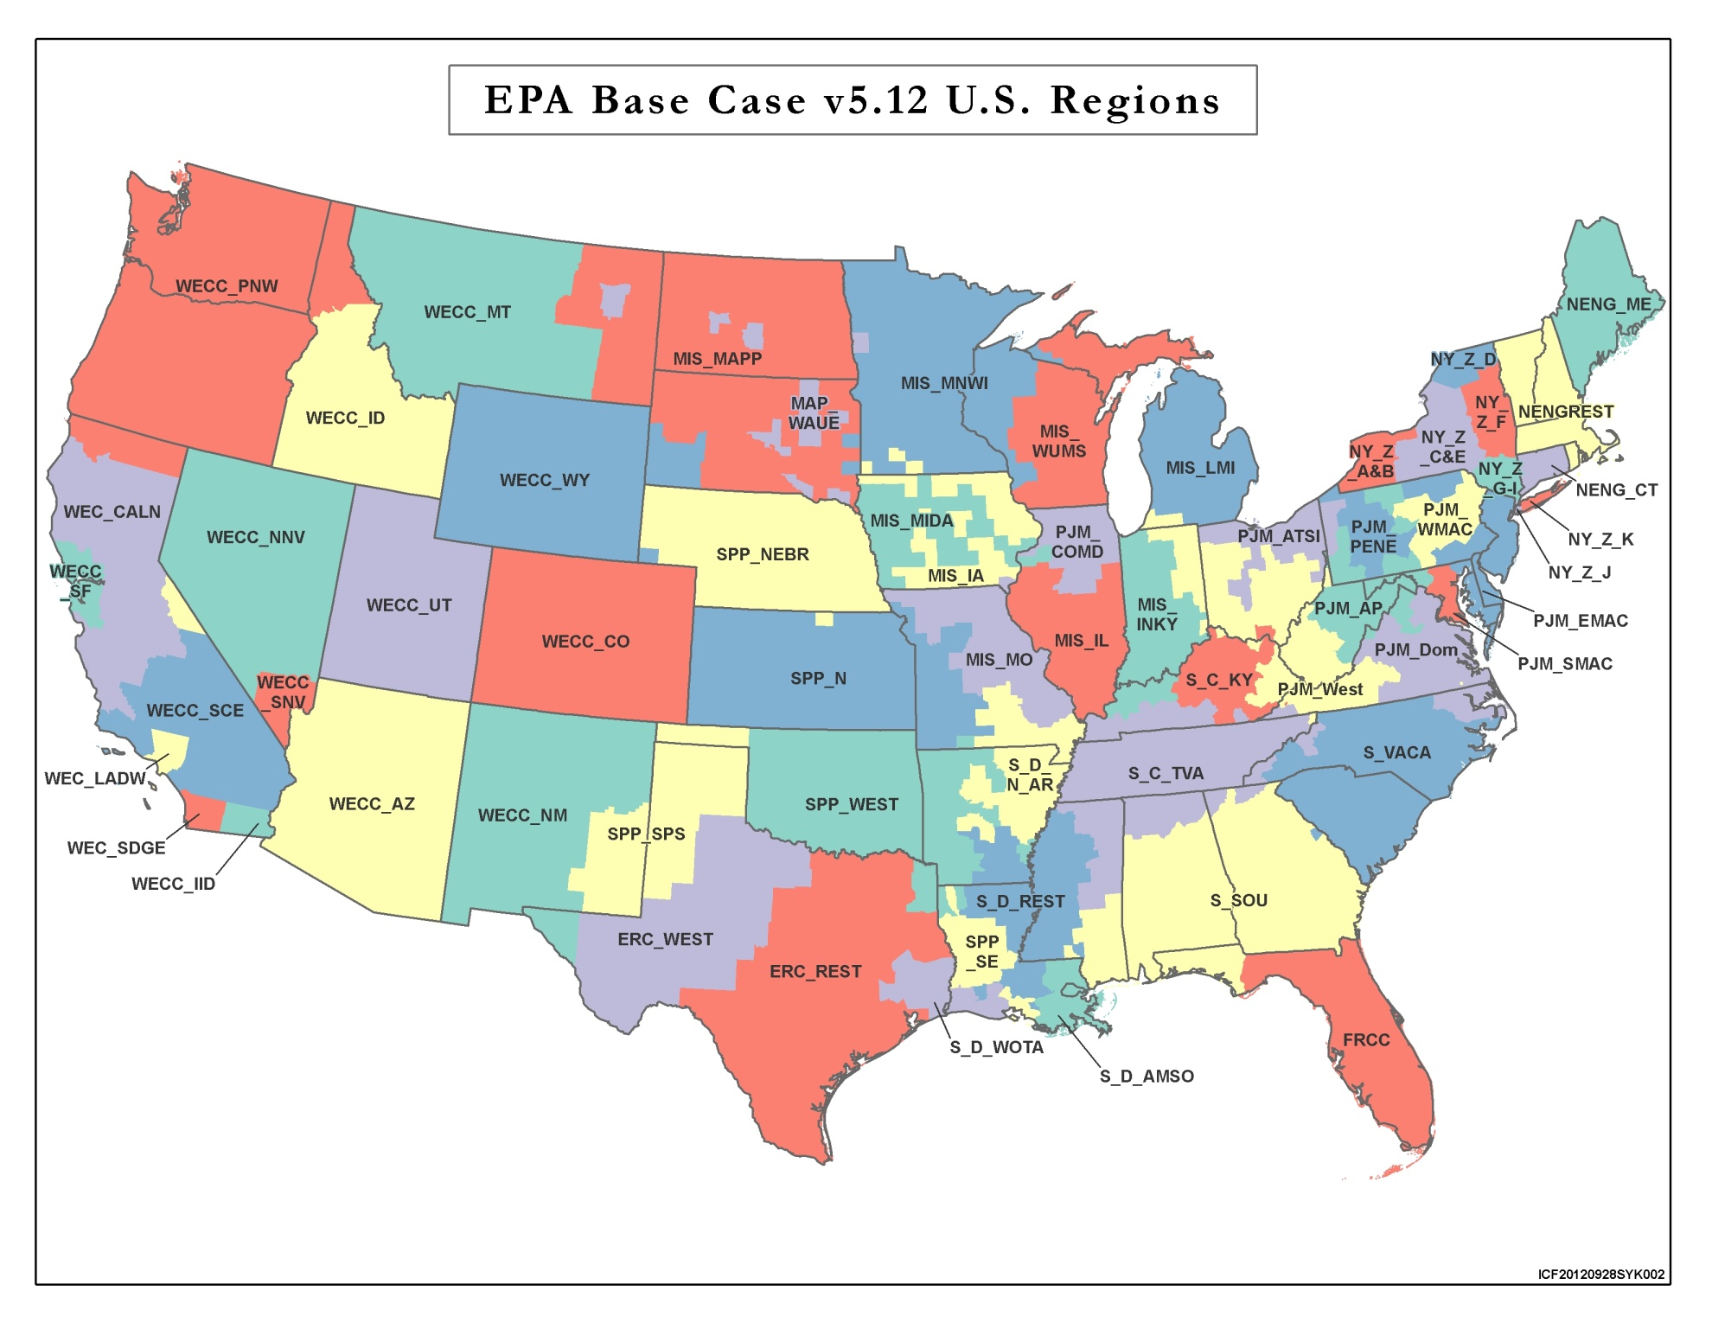

**C2: NERC Assessment Areas in Long Term Reliability Assessment.**

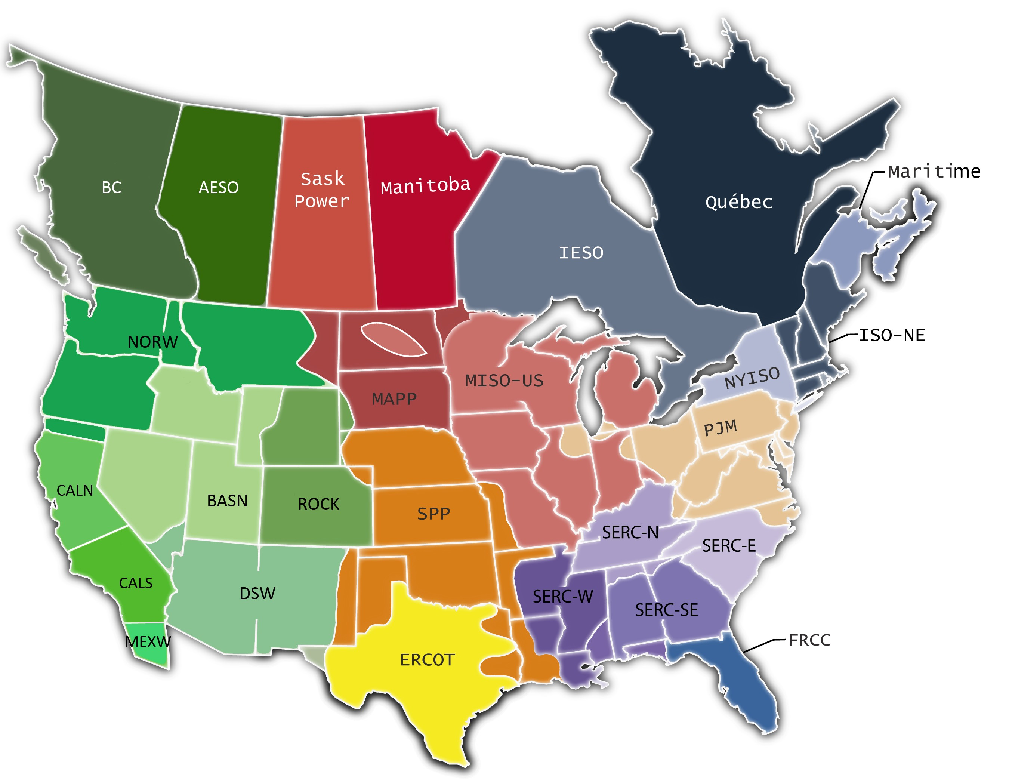

Source: NERC 2012 Long Term Reliability Assessment

1. As analyzed in this document, power regions correspond to aggregates of IPM regions corresponding to NERC assessment areas.
2. Both the base and policy cases start from input data on the expected state of the fleet of power plants in 2016 and assume certain planned retirements and additions happen by the end of 2015; the analysis focuses on the impacts of retirements that are projected by the IPM model in the 2020, 2025 and 2030. See the documentation of the NEEDS data base at [epa.gov/powersectormodeling](https://epa.gov/powersectormodeling) for information on what retirements and additions are assumed to occur by the end of 2015.
3. See final rule Regulatory Impact Analysis for more detail on the power sector impacts of the final CPP.
4. Detailed information and documentation of EPA’s Base Case using IPM (v5.13), including all the underlying assumptions, data sources, and architecture parameters can be found on EPA’s website at: http://www.epa.gov/powersectormodeling/BaseCasev513.html
5. See Chapter 3 of the RIA for additional detail on the scenarios analyzed.
6. Operational capacity is any existing, new or retrofitted capacity that is not retired.
7. Numbers in this table may not sum to numbers in Table A1 due to independent rounding and small classification differences between the base and policy cases.
8. Reserve margin targets are generally based on the NERC 2010 10 Year Assessments for the region, except in cases where there are more stringent state requirements or other exceptions.
9. Regional data on operational capacity is shown in Table A1 of the Appendix.
10. The reserve contribution to reserve capacity requirements from energy efficiency is determined by the reduced peak demand and the target reserve margin in each region. For example, if peak demand in reduced by 100 MW and the reserve margin percentage in a region is 15%, the reduction in reserve capacity requirements is 115MW.
11. See maps of IPM regions and NERC Assessment Regions, and the table of target and projected reserve margins in the Appendix C. IPM regions are based on the regions NERC uses for regional assessments. These Assessment Regions are used for the Appendix tables in this document.
12. Retirement and additions in this section are all incremental to the base case in 2025; the MW values represent model projections of responses to the imposition of the policy, not currently announced retirements or additions that are currently planned or under construction.
13. See the Resource Adequacy and Reliability Analysis for the proposed rule. A level of 5% was used as a screen in that analysis; given the length of time to plan for compliance with this rule, a 5% shift is expected to be manageable within normal system planning timeframes. In the proposed rule TSD, there were three regions above the 5% threshold.
14. For more detail on differences between these scenarios, including the specific scenarios modeled, the modeling assumptions, and impacts, see the Regulatory Impact Analysis, Chapter 3.