**Surface and Active Layer Pore Water Chemistry from Ice Wedge Polygons, Barrow, Alaska, 2013-2014**

## Review and follow the current NGEE Data and Fair-Use Policies prior to using these data ([http://ngee-arctic.ornl.gov/content/ngee-arctic-](http://ngee-arctic.ornl.gov/content/ngee-arctic-data-management-policies-and-plans) [data-management-policies-and-plans](http://ngee-arctic.ornl.gov/content/ngee-arctic-data-management-policies-and-plans)).

**Summary:**

This data set reports the results of spatial surveys of aqueous geochemistry conducted at Intensive Site 1 of the Barrow Environmental Observatory in 2013 and 2014 (Herndon et al., 2015). Surface water and soil pore water samples were collected from multiple depths within the tundra active layer of different microtopographic features (troughs, ridges, center) of a low-centered polygon (area A), high-centered polygon (area B), flat-centered polygon (area C), and transitional polygon (area D). Reported analytes include dissolved organic and inorganic carbon, dissolved carbon dioxide and methane, major inorganic anions, and major and minor cations.

The study by Herndon et al. (2015) focused on interactions between Fe and organic C geochemistry. Results indicated that differences in water saturation across microtopographic units generate vertical redox gradients that control Fe speciation, which in turn influences microbial production of carbon dioxide and methane from carbon substrates in the soil. Fe-reduction deep in the mineral horizon of the active layer produces Fe(II) that diffuses upwards in the soil profile and is oxidized to form iron oxyhydroxide and organic-Fe(III) complexes in the organic horizon. Enrichment of oxidized Fe in the organic horizon influences organic matter decomposition by providing an abundant terminal electron acceptor microbial decomposition, by providing reactive surfaces that sorb organic compounds, and by facilitating electron transfer that may enhance methanogenesis.

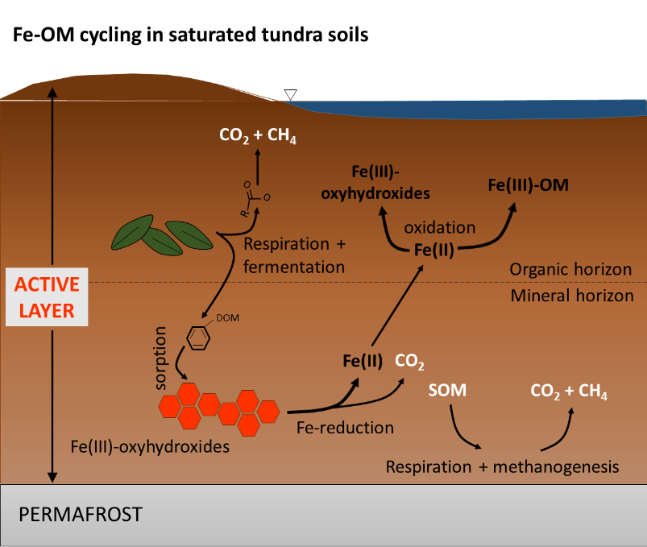

Figure 1. Conceptual model of Fe and organic carbon cycling in the active layer of a low-centered polygon. From Herndon et al., 2015.

# Please use this citation to reference the data:

Herndon, Elizabeth M., Ziming Yang, David E. Graham, Stan D. Wullschleger, Baohua Gu, and Liyuan Liang. 2016. Surface and Active Layer Pore Water Chemistry from Ice Wedge Polygons, Barrow, Alaska, 2013-2014.Next Generation Ecosystem Experiments Arctic Data Collection, Carbon Dioxide Information Analysis Center, Oak Ridge National Laboratory, Oak Ridge, Tennessee, USA. Data set accessed at <http://dx.doi.org/10.5440/1226245>.

# Please use this citation for the related publication:

Herndon, Elizabeth M., Ziming Yang, John Bargar, Noemie Janot, Tom Z. Regier, David E. Graham, Stan D. Wullschleger, Baohua Gu, and Liyuan Liang. "Geochemical drivers of organic matter decomposition in arctic tundra soils." *Biogeochemistry* 126, no. 3 (2015): 397-414. <http://dx.doi.org/10.1007/s10533-015-0165-5>

# Data Characteristics:

There is one comma-separated (.csv) file provided with this data set.

BGC_BarrowWaterChemistry_2013_2014_v1.csv

For certain measured variables, a quality flag, *_fl, is also reported. The flag may have the following values:

V0 = valid value;

V1 = valid value but comprised wholly or partially of below detection limit data;

V7 = valid value but set equal to the detection limit (DL) because the measured value was below the detection limit; and

M1 = missing value because no value is available (not analyzed).

**Data Dictionary:**

| **Column Name** | **Units/Format** | **Description** |
| --- | --- | --- |
| Sample_ID |  | NGEE Arctic sample identifier |
| Latitude | decimal degrees | Latitude coordinates for sample collection |
| Longitude | decimal degrees | Longitude coordinates for sample collection |
| Sampling_Date | YYYY-MM-DD | Date of sample collection |
| Region |  | North Slope |
| Locale |  | Barrow |
| Site |  | Intensive Site 1 |
| Area |  | A, B, C, or D |
| Polygon_type |  | Low-centered, high-centered, flat-centered, or transitional |
| Microtopography |  | Trough, ridge, or center position |
| Collection_type |  | Identifies method of sample collection: surface, rhizon sampler, soil gas sampler, piezometer |
| Depth_designation |  | Surface, shallow, middle, or deep; refers to relative depth below land surface |
| Sample_depth_max | cm | Depth from the soil surface (= 0 cm) to the bottom of the sampling device |
| Specific_conductance | μS cm-1 | Measurement on unfiltered waters |
| Specific_conductance_fl |  | Quality flag |
| Sample_temperature | degrees Celsius | Temperature of sampled water measured in field |
| Sample_temperature_fl |  | Quality flag |
| pH_lab |  | pH of filtered water measured in the lab on the same day as sample collection |
| pH_lab_fl |  | Quality flag |
| Dissolved_CO2 | mmol L-1 | Concentration of carbon dioxide gas dissolved in water |
| Dissolved_CO2_fl |  | Quality flag |
| Dissovled_CH4 | mmol L-1 | Concentration of methane gas dissolved in water |
| Dissovled_CH4_fl |  | Quality flag |
| Dissolved_inorganic_C | mmol L-1 | Concentration of dissolved inorganic carbon species |
| Dissolved_inorganic_C_fl |  | Quality flag |
| Dissolved_organic_C | mmol L-1 | Concentration of dissolved organic carbon species |
| Dissolved_organic_C_fl |  | Quality flag |
| Chloride | mmol L-1 | Concentration of dissolved (< 0.45 μm) chloride |
| Chloride_fl |  | Quality flag |
| Bromide | μmol L-1 | Concentration of dissolved (< 0.45 μm) bromide |
| Bromide_fl |  | Quality flag |
| Nitrate | μmol L-1 | Concentration of dissolved (< 0.45 μm) nitrate |
| Nitrate_fl |  | Quality flag |
| Sulfate | μmol L-1 | Concentration of dissolved (< 0.45 μm) sulfate |
| Sulfate_fl |  | Quality flag |
| Phosphate | μmol L-1 | Concentration of dissolved (< 0.45 μm) phosphate |
| Phosphate_fl |  | Quality flag |
| Aluminum | mmol L-1 | Concentration of dissolved (< 0.45 μm) aluminum |
| Alumnium_fl |  | Quality flag |
| Iron_total | mmol L-1 | Concentration of dissolved (< 0.45 μm) total iron |
| Iron_total_fl |  | Quality flag |
| Iron_ferrous | mmol L-1 | Concentration of dissolved (< 0.45 μm) ferrous iron |
| Iron_ferrous_fl |  | Quality flag |
| Sodium | mmol L-1 | Concentration of dissolved (< 0.45 μm) sodium |
| Sodium_fl |  | Quality flag |
| Magnesium | mmol L-1 | Concentration of dissolved (< 0.45 μm) magnesium |
| Magnesium_fl |  | Quality flag |
| Calcium | mmol L-1 | Concentration of dissolved (< 0.45 μm) calcium |
| Calcium_fl |  | Quality flag |
| Potassium | mmol L-1 | Concentration of dissolved (< 0.45 μm) potassium |
| Potassium_fl |  | Quality flag |
| Lithium | μmol L-1 | Concentration of dissolved (< 0.45 μm) lithium |
| Lithium_fl |  | Quality flag |
| Chromium | μmol L-1 | Concentration of dissolved (< 0.45 μm) chromium |
| Chromium_fl |  | Quality flag |
| Manganese | μmol L-1 | Concentration of dissolved (< 0.45 μm) manganese |
| Manganese_fl |  | Quality flag |
| Nickel | μmol L-1 | Concentration of dissolved (< 0.45 μm) nickel |
| Nickel_fl |  | Quality flag |
| Cobalt | μmol L-1 | Concentration of dissolved (< 0.45 μm) cobalt |
| Cobalt_fl |  | Quality flag |
| Copper | μmol L-1 | Concentration of dissolved (< 0.45 μm) copper |
| Copper_fl |  | Quality flag |
| Zinc | μmol L-1 | Concentration of dissolved (< 0.45 μm) zinc |
| Zinc_fl |  | Quality flag |
| Gallium | μmol L-1 | Concentration of dissolved (< 0.45 μm) gallium |
| Gallium_fl |  | Quality flag |
| Arsenic | μmol L-1 | Concentration of dissolved (< 0.45 μm) arsenic |
| Arsenic_fl |  | Quality flag |
| Selenium | μmol L-1 | Concentration of dissolved (< 0.45 μm) selenium |
| Selenium_fl |  | Quality flag |
| Strontium | μmol L-1 | Concentration of dissolved (< 0.45 μm) strontium |
| Strontium_fl |  | Quality flag |
| Barium | μmol L-1 | Concentration of dissolved (< 0.45 μm) barium |
| Barium_fl |  | Quality flag |
| Lead | μmol L-1 | Concentration of dissolved (< 0.45 μm) lead |
| Lead_fl |  | Quality flag |

**Data were not blank corrected.**

|  |  |  |
| --- | --- | --- |
| **Analyte** | **Units/Format** | **Detection Limit** |
| Lead | μmol L-1 | 0.02 |
| Barium | μmol L-1 | 0.04 |
| Strontium | μmol L-1 | 0.06 |
| Selenium | μmol L-1 | 0.06 |
| Arsenic | μmol L-1 | 0.07 |
| Gallium | μmol L-1 | 0.07 |
| Zinc | μmol L-1 | 0.08 |
| Copper | μmol L-1 | 0.08 |
| Cobalt | μmol L-1 | 0.09 |
| Nickel | μmol L-1 | 0.09 |
| Manganese | μmol L-1 | 0.09 |
| Chromium | μmol L-1 | 0.10 |
| Lithium | μmol L-1 | 0.72 |
| Potassium | mmol L-1 | 0.003 |
| Calcium | mmol L-1 | 0.003 |
| Magnesium | mmol L-1 | 0.004 |
| Sodium | mmol L-1 | 0.004 |
| Iron_ferrous | mmol L-1 | 0.01 |
| Iron_total | mmol L-1 | 0.002 |
| Aluminum | mmol L-1 | 0.004 |
| Sulfate | μmol L-1 | 1.00 |
| Chloride | μmol L-1 | 1.00 |
| Phosphate | μmol L-1 | 1.00 |
| Sulfate | μmol L-1 | 1.00 |
| Nitrate | μmol L-1 | 1.00 |
| Bromide | μmol L-1 | 1.00 |
| Dissolved organic carbon | mmol L-1 | 0.08 |
| Dissolved inorganic carbon | mmol L-1 | 0.08 |

**Data Acquisition Materials and Methods:**

Water sampling methods and analytical techniques are described in detail in Herndon et al., 2015. Figures 2 and 3 below are included to provide the user with clear descriptions of the sampled polygon types and their microtopographic features.



**Figure 2**. Photographs were taken at each sampled polygon in late August 2014 and display standing water in the low-centered (A) and transitional (D) polygons. Ridge (R), trough (T), and center (C) microtopographic features are labeled in each photograph. (Figure S1 from Herndon et al., 2015)



**Figure 3.** Additional characterization of sampling locations. (From Herndon et al., 2015)

1. Colored boxes on the relief map of the Barrow Environmental Observatory indicate field sampling areas.

* Values for volumetric soil moisture (m3/m3) were measured in surface soils (< 10 cm) at each site in early July.
* LiDAR image provided courtesy of Garrett Altmann (Los Alamos National Laboratory) and Craig Tweedie (University of Texas El Paso).

1. Diagrams of the different polygon types sampled in this study.

* Each box contains a cartoon of a polygon in cross-section view to highlight the relative elevations of the microtopographic features (ridge, center, trough) present in each polygon type. Elevation differences are not to scale.

1. The graph indicates maximum thaw depth measured at each topographic position (indicated by a T, C, or R) at each sampling site in early July (black bar) and late August (white bar)

# References:

Herndon, Elizabeth M., Ziming Yang, John Bargar, Noemie Janot, Tom Z. Regier, David E. Graham, Stan D. Wullschleger, Baohua Gu, and Liyuan Liang. "Geochemical drivers of organic matter decomposition in arctic tundra soils." *Biogeochemistry* 126, no. 3 (2015): 397-414. <http://dx.doi.org/10.1007/s10533-015-0165-5>

# Data Access:

## Disclaimer of Liability

Data and documents available from the NGEE Arctic web site (<http://ngee.ornl.gov/)> were prepared as an account of work sponsored by an agency of the U.S. Government. Neither the

U.S. Government nor any agency thereof, or any of their employees, makes any warranty, express or implied, or assumes any legal liability or responsibility for the accuracy, completeness, or usefulness of any information, apparatus, product, or process disclosed, or represents that its use would not infringe privately owned rights. Further, Oak Ridge National Laboratory is not responsible for the contents of any off-site pages referenced.

The complete ORNL disclaimer can be viewed at <http://www.ornl.gov/ornlhome/disclaimers.shtml>.

# Data Center Contact:

[support@ngee-arctic.ornl.gov](mailto:support@ngee-arctic.ornl.gov)